**Object-oriented programming ex2**

Submitted by:

Ely Asaraf, ID: 319027355

Nadav Malul, ID: 206762973

**Intro**

In this exercise we created a Console terminal which Is used to help students apply for a year at college. The student inserts the necessary details such as id, name etc.

As a part of a form validation process the program validates the given information. If any field of information is missing/incorrect the program will give the user another chance of giving the right information.

Once the student inserts a valid form, the program will display the given form as output (and finish).

**Program Design:**

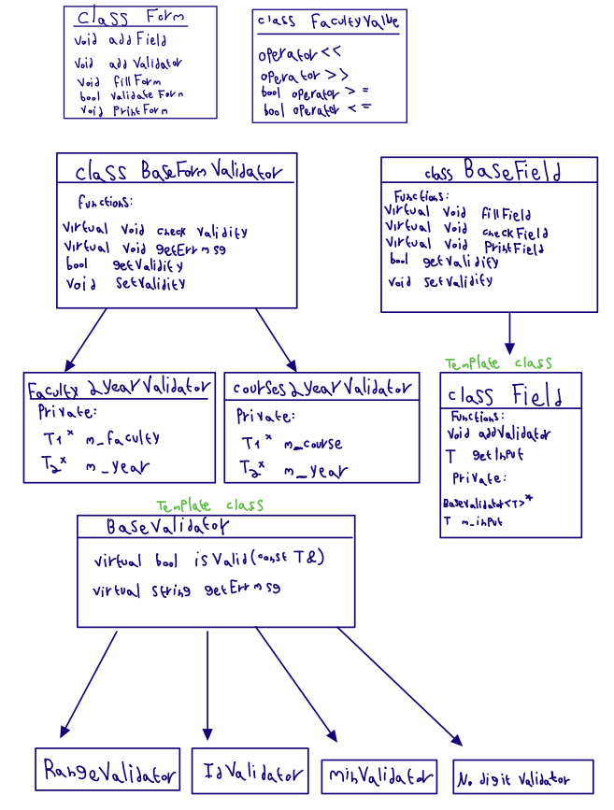

**Classes:**

**Class Form:**

This class represents the form.

This is a non-template class, represents a form which contains many fields of information, those fields are kept inside of a BaseField* vector. Each element from this vector is a pointer to a BaseField class which will be explained below.

**Class BaseField:**

BaseField class represents a field in the form, each field in the form needs to be checked differently hence BaseField contains validity functions and virtual validity-check virtual functions (which will be overrode later).

**Class Field (a template class):**

Class field inherits from BaseField.

The class contains a private "T" variable which is the given input for some field in the form, for example: it could be the users name, id, year of birth etc.

Each field also contains a private pointer to a BaseValidator* which will contain the relevant validator to the given field, each field type has only one relevant validator.

Class functions:

fillField: inserts the quote output for the expected input, held by a private string.

checkField: checks the validity of the field by using the validator isValid check function.

**Class BaseValidator(a template class):**

Is a base template class which contains a virtual check function and its related error message.

The validators that inherit from this class are: RangeValidator, IDValidator, MinValidator, NodigitValidator

**Class BaseFormValidator**:

This is the base class for classes "Faculty2YearValidator" and "Courses2YearValidator" this class contains the virtual functions:  
"checkValidity", "getErrMsg", "resetFields"

**Worth Mentioning data structures:**

a unique_ptr vector of BaseFormValidator* (as private member).

All the given fields are held by a unique ptr vector of baseField*.

Both are in class "Form".

In addition, every field contains a vector of its validators.

**Worth Mentioning Algorithms:**

Check id algorithm- implemented by the Wikipedia given version as suggested in the exercise.

**Known bugs:**

Currently there are no known bugs in the current version.

**Other notes:**

None.